# HMM models of protein family to detect remote homologs

Overview: In the previous exercise we used premade motif models to screen our sequence against.

Here we will perform the full analysis ourselves:

We will start with one member of a protein family. We will collect members of the same protein family using the NCBI website. We will align the members of the family using a multiple sequence alignment tool ClustalOmega). Subsequently we will convert the multiple alignment into a HMM and use this model to search for remote homologs of the protein family. We will first solve the exercise using webtools. subsequently redo the analysis using command line tools (with introduction to linux).

**Exercise 1** (use webinterface): Search for additional proteins that belong to the family of Rieske iron sulfur proteins. To this end start with the following genuine Rieske iron sulfur proteins (i.e. proteins you know that belong to the family): NCBI: P08067, P20788, AAD55565, P08980, P23136, AAC84018, AAF02198.

How will you proceed?

Solution:

a) download the sequences in FASTA format from ncbi

b) make a multiple alignment from those proteins

c) extract from the multiple alignment a HMM of the most conserved region (use clustalomega)

d) screen the database with this HMM to search for more remote members of the family

a) To download the sequences we will use the batch entrez (https://www.ncbi.nlm.nih.gov/sites/batchentrez). This tool allows you to download in batch a set of sequences for which the accession numbers are provided in a text file (Rieske_accessionnumberlist.txt).

Import the text file and indicate you want to download the protein sequences.

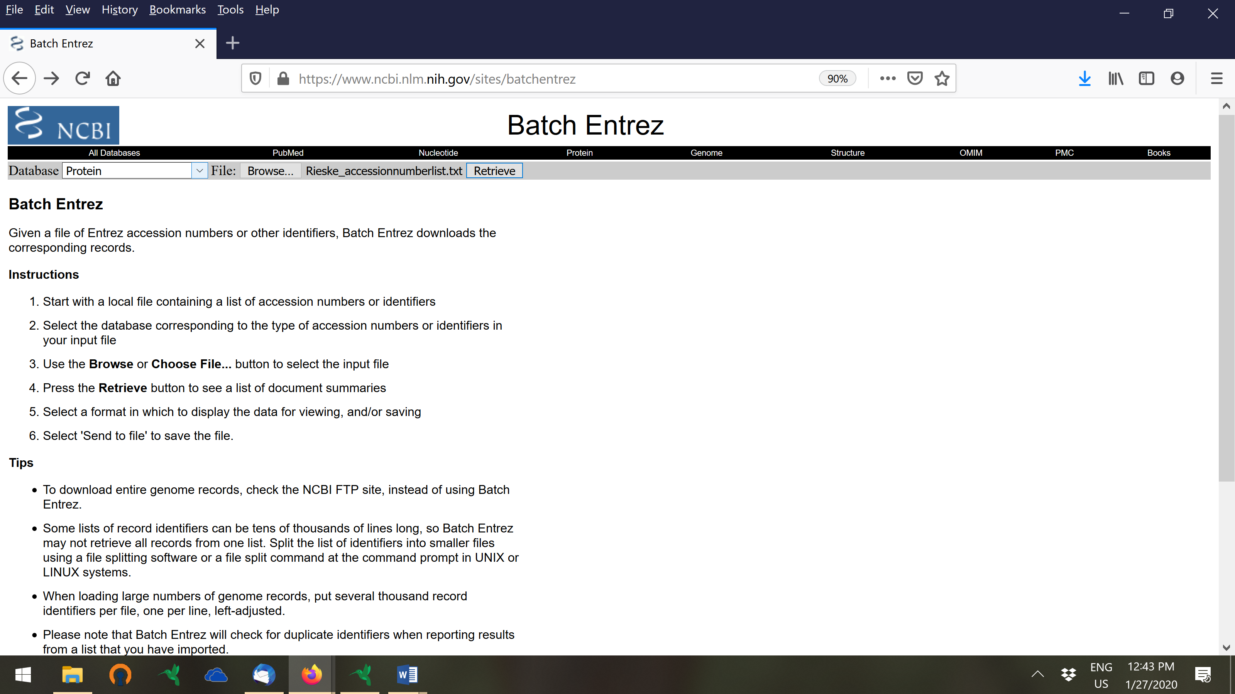

Entrez retrieves the sequences corresponding to the accession numbers in your file. Subsequently select all entries and export the data in FASTA format to a text file. Make sure you perform your search in the protein database. Use the ‘send to’ function.

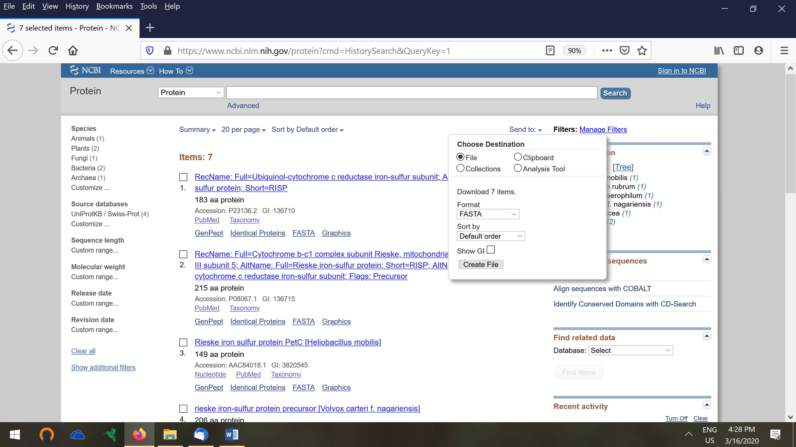

Check whether all sequences are in the correct format in the FASTA file (proteinlistRieske_FASTA.txt).

Subsequently perform the multiple alignment with clustalomega (http://www.ebi.ac.uk/Tools/msa/clustalo/). Save the alignment file in standard clustalomega format (clustalo-I20171127-090954-0236-64563528-pg) with the tab ‘download alignment file’

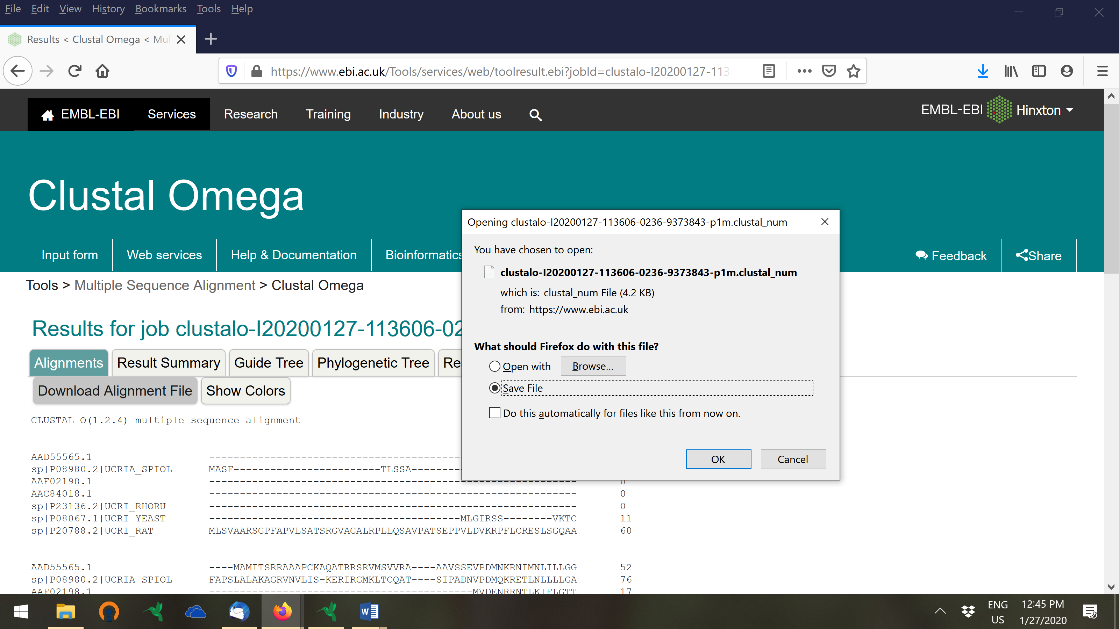

The tool HMMERsearch performs simultaneously a) the extraction of the HMM from the multiple sequence alignment (which you just made using clustalomega) and b) the screening of a protein database with the detected HMM. Import your alignment file in HMMSearch (https://www.ebi.ac.uk/Tools/hmmer/search/hmmsearch).



Interpret the output.

* How many hits did you obtain (see bottom of the page)?



* In which species did you detect a hit. Which group of species have the lowest hit scores? (eukaryotes)-> see plot below

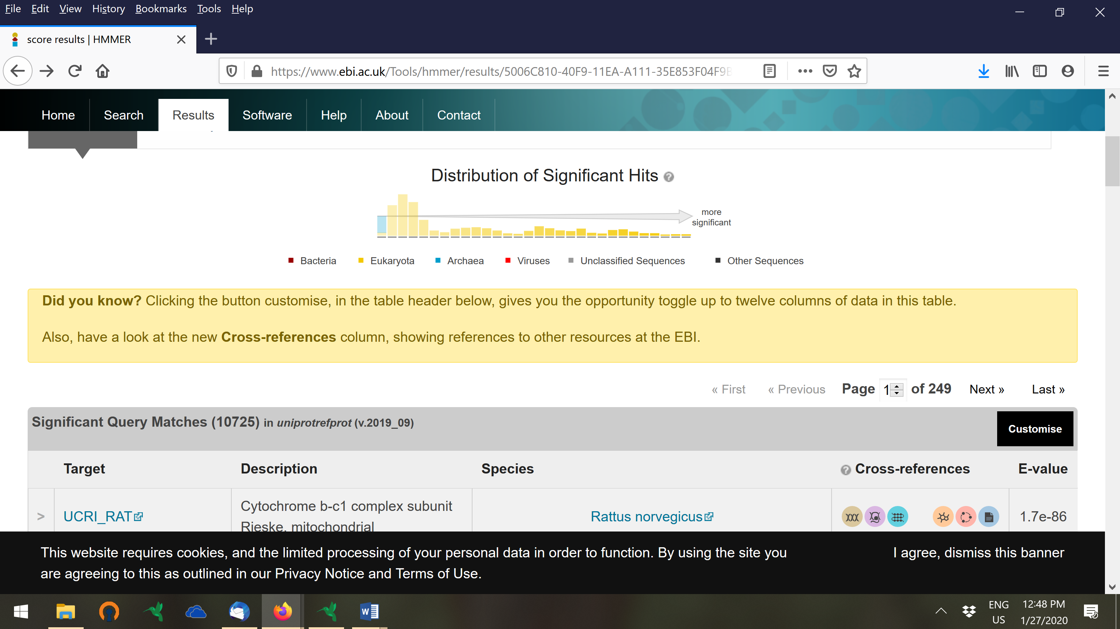

What is the meaning of the E-value

Compare the e value of the best hit with the one of the worst hit.

Best hits:

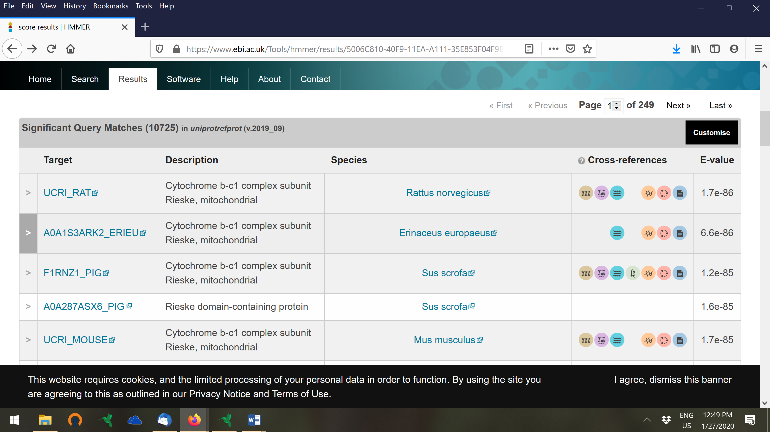

Worst hits:

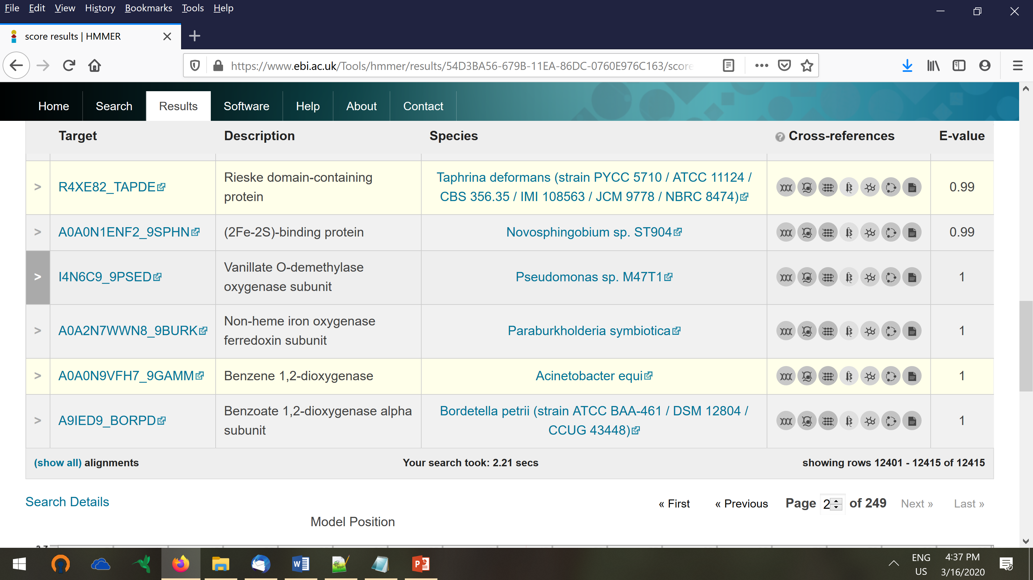

* Interpret the logo (at the bottom of the results page)

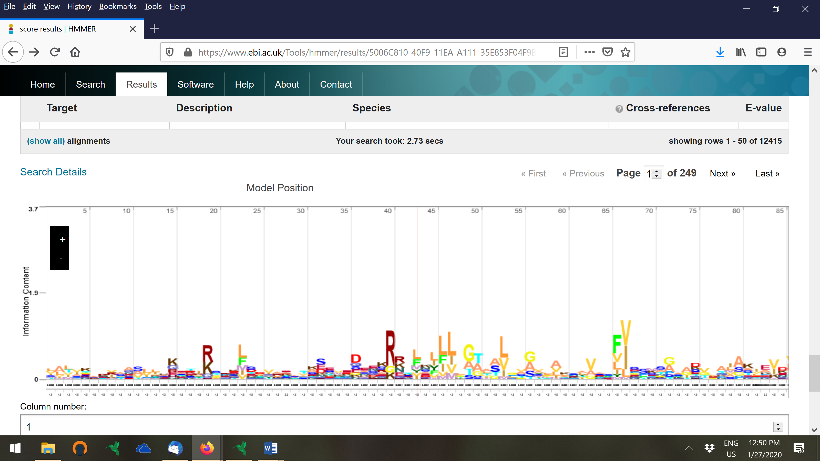

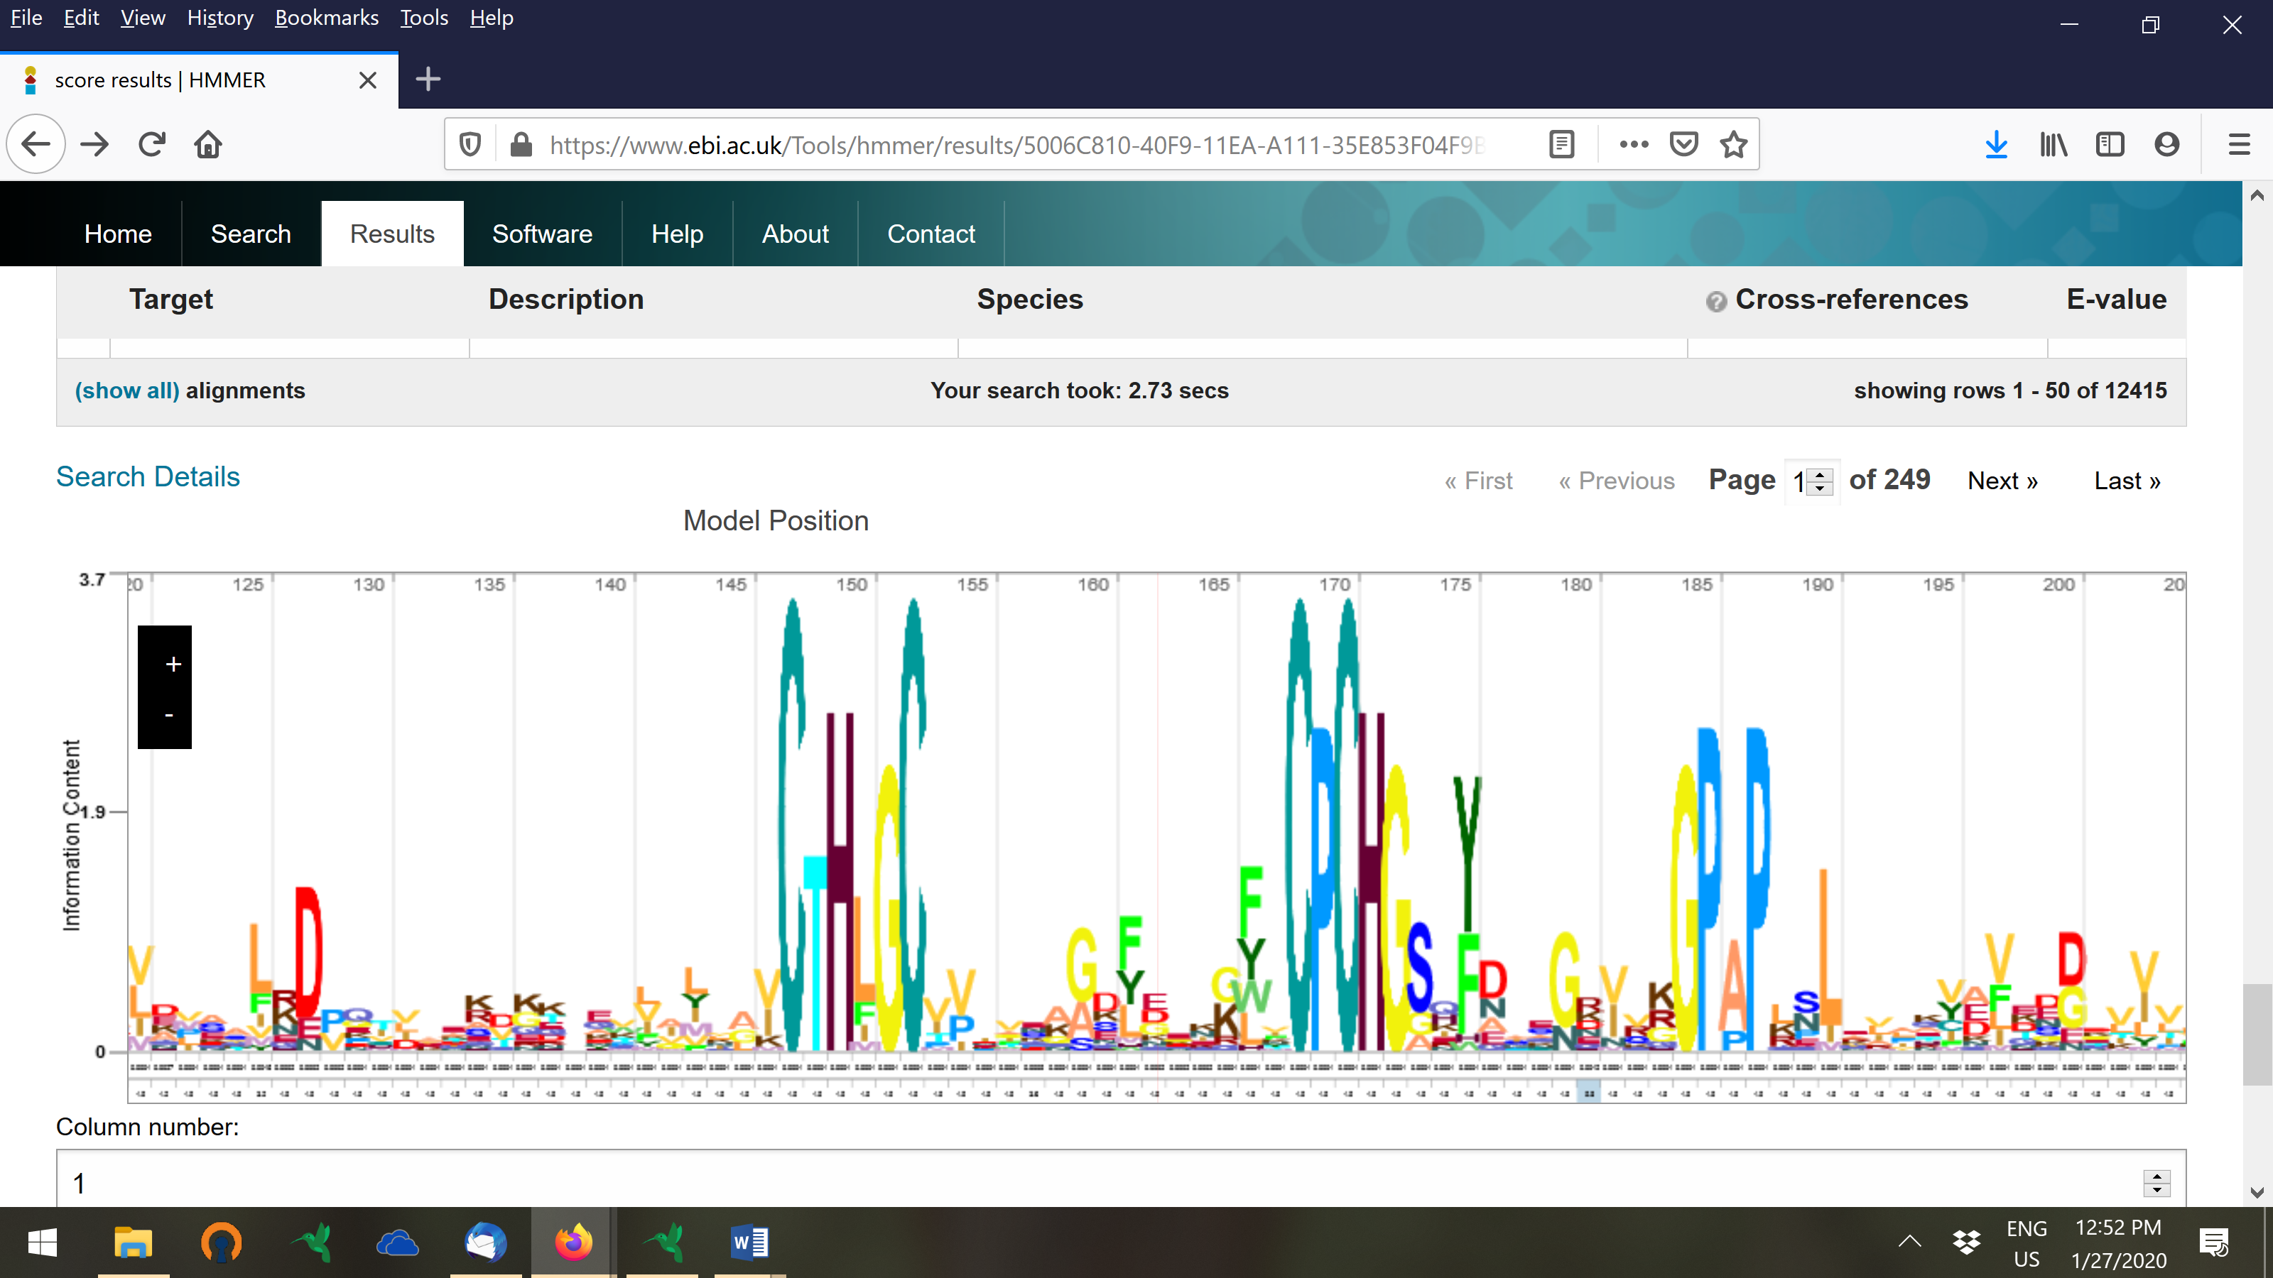

Rieske protein has an iron-sulfur center that binds 2Fe-2S. The amino acid binding motifs are known to have the consensus C-X-H-X-G-C and C-X-X-H. Do you find these back? (scroll on the logo image to find the more conserved positions).

Note that the motif logo is built in the same way as for nucleotide motifs except that we use Di= log2(20)-Hi. So suppose a position in the alignment is perfectly conserved (fbi=1)=> then the score becomes log2(20)-1Xlog2(1) -0Xlog2(0). => 1Xlog2(1) = 0 and 0Xlog2(0) approximates 0 (if there are only pseudocunts). So the max stack hight of a column is log2(20) = 4.3 (not accounting for psuedocounts)



Log2

For this exercise you should know what the underlying flow is. What have you been doing.

**Exercise 2**: in the previous section we have made a HMM of a protein family in order to screen remote homologs from the same family. Using a webinterface is convenient if one only has to analyse a single protein. However, if one want to analyse or annotate a full genome it is much more convenient to use command line tools. Blast, ClustalW, HMMEr all also exist in command line. This will be illustrated below. [LIEVEN]